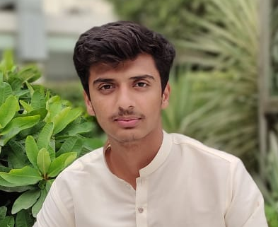

CONTACT INFO

Hamzaazeez21@gmail.com
03098807075

Islam Nagar walton road Lahore Cantt Pakistan

PERSONAL

Optimistic
Exactitude
Creative
Communicative
Confident

Hamza Aziz

OBJECTIVE

Seeking a challenging career within a dynamic and progressive environment where, there is a maximum chance of learning and co-operative environment of organization to enhance my skills and develop successful attitude towards living on the edge by getting job as well as to enhance my experience.

EDUCATION

INTERMEDIATE| Superior Group of Colleges ICS year(2020-2022)

MATRIC| Unique School Lahore year(2019) Computer science
EXPERIENCE
- Call center job
- Sales Marketing
- Home tuitions

SKILLS
Self motivation, initiative with a high level of energy.
Verbal communication skills.
Microsoft Office PowerPoint
Microsoft Office Word
Microsoft Office Excel

CO-CURRICULAR ACTIVITIES
- Writing skill
- Data Collection
- Browsing internet
- Typing

LANGUAGES
Urdu, English Languages and Punjabi

